**How to Design and Draw Sheet Metal Parts**

*Subject to slightly change with new sponsors*

Made by: Mark Diny

Year: 221 Season

Supplier: Cole Manufacturing

Table of Contents

Designing Sheet Metal Parts 2

Bend Radius and K Factor 5

Poor Design Example 8

Making a Part Drawing 11

Sheet 1: Formed Part Drawing 14

Tolerance/Dimensioning Formed Part Drawings 15

Sheet 2: Laser Cut Part Drawing 19

Tolerance/Dimensioning Laser Cut Drawings 21

Changing dimensions to show outside radius, not center of arc 24

EMP Lead Time (and most lead times) 25

# Designing Sheet Metal Parts

1. **UPDATE YOUR DRAWING TEMPLATES PER THE OTHER DOCUMENT IN THIS FOLDER: “How To - Installing Templates and Formats”**
2. Make a new part. Right click on toolbar to activate the “Sheet Metal” tab

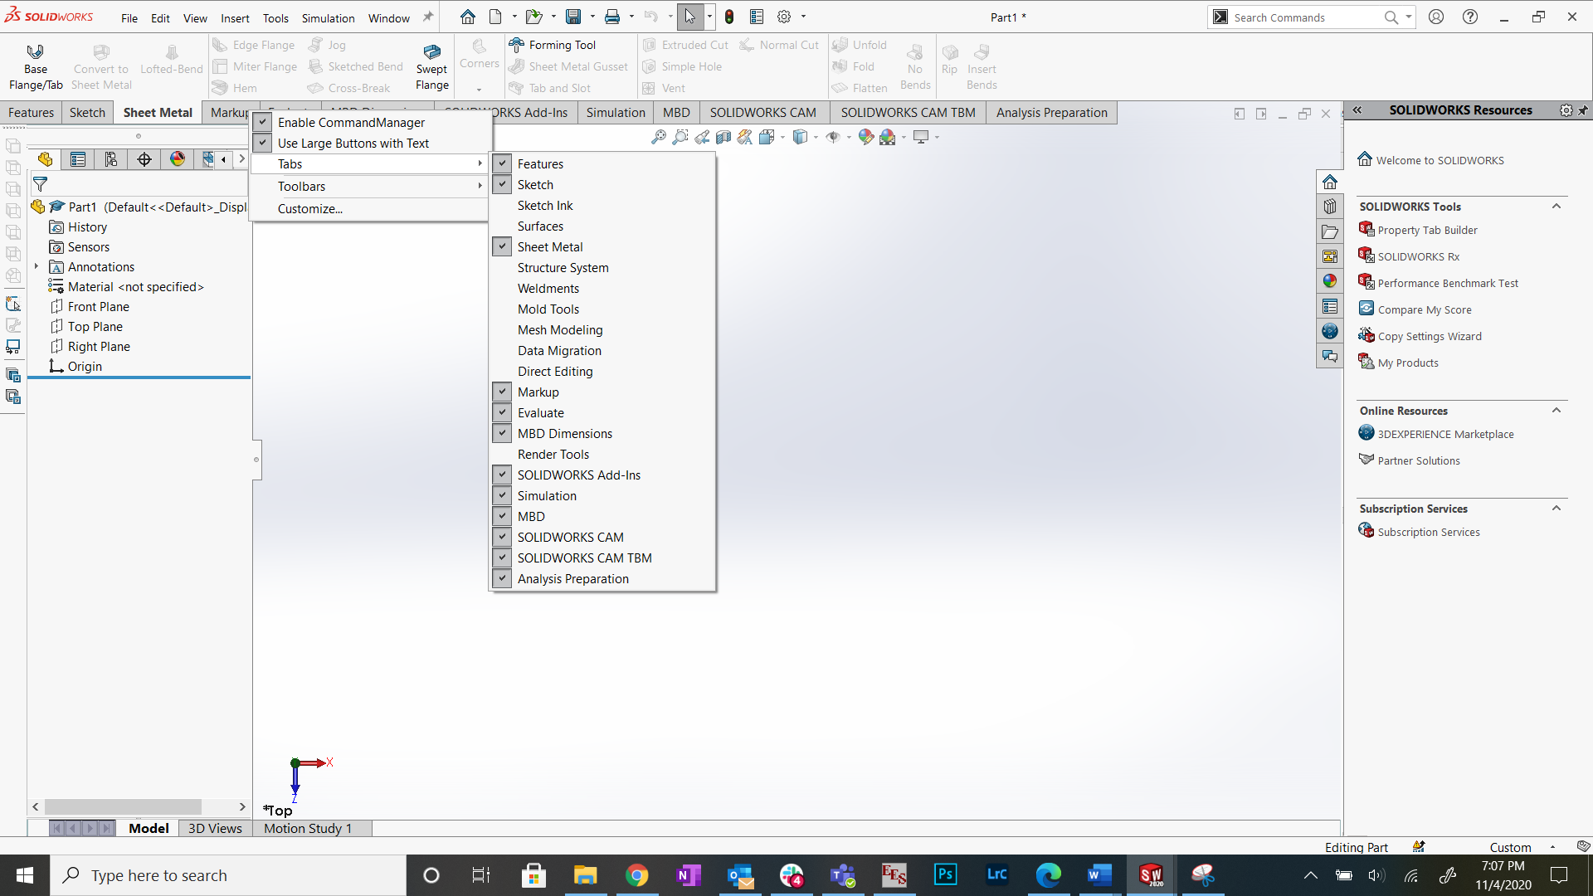



1. To start making a part, click “Base Flange/Tab”.

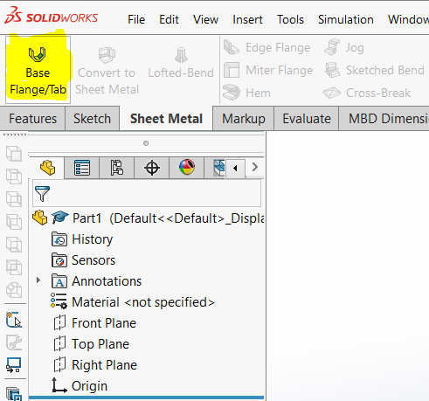

1. Make a sketch, fully define it. Exit the sketch.
   1. SW will prompt you to give the thickness of the sheet metal. Do this, then click the green check mark.

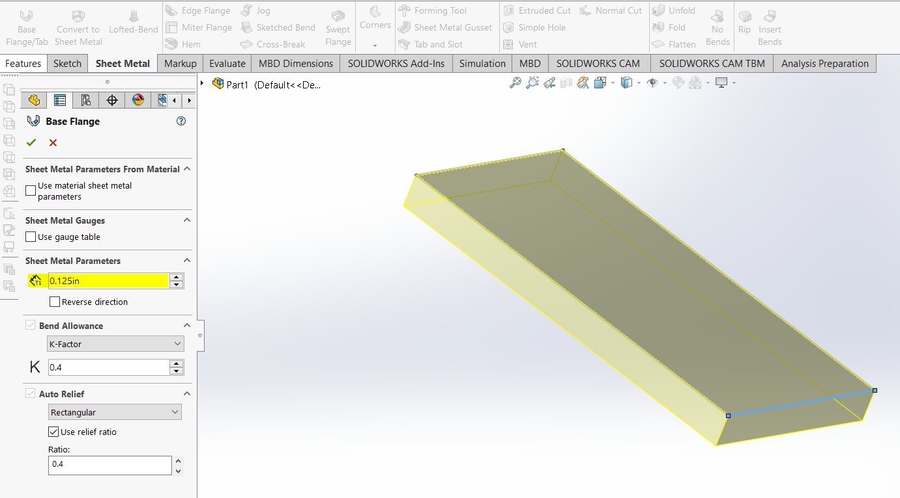

## Bend Radius and K Factor

1. Right click on “Sheet-Metal” in the model tree and click “Edit Feature”
   1. Enter the bend radius and k factor based off the material thickness
   2. 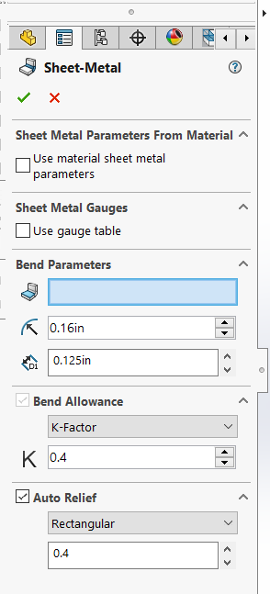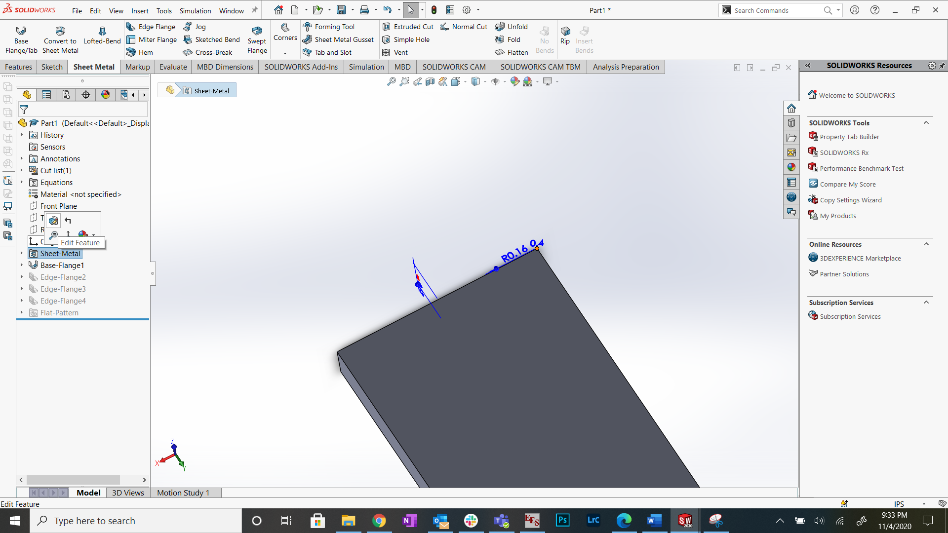Bend radius and k factor are below. Subject to change based on what company makes the parts



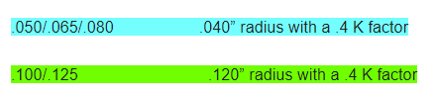

\*\***Values given to us in 221 by supplier Cole Manufacturing, subject to change based on sponsor\*\***



1. To add flanges, click “Edge Flange” and click any line of an edge that you want the flange to come from

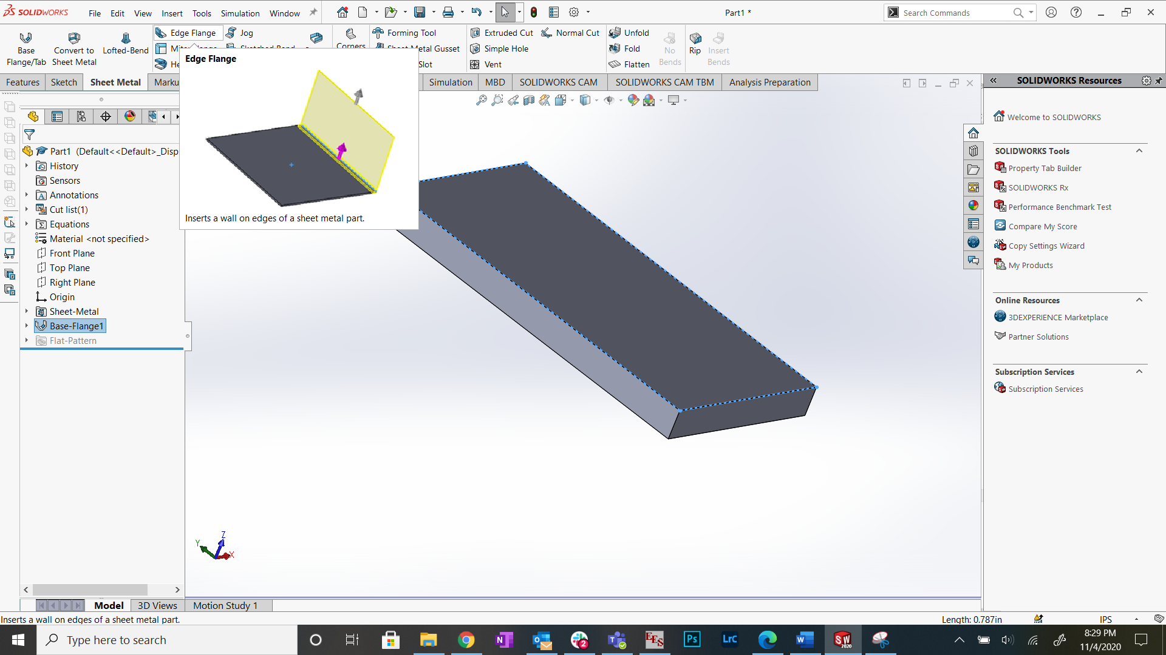



1. Change the length and flange position
   1. Be sure to select the second “Flange Position” (shown in yellow) if you can. This way if we ever must change the bend radius, the position of the flange does not change. SW would move the flange if this wasn’t selected, makes life hard when changing the bend radius

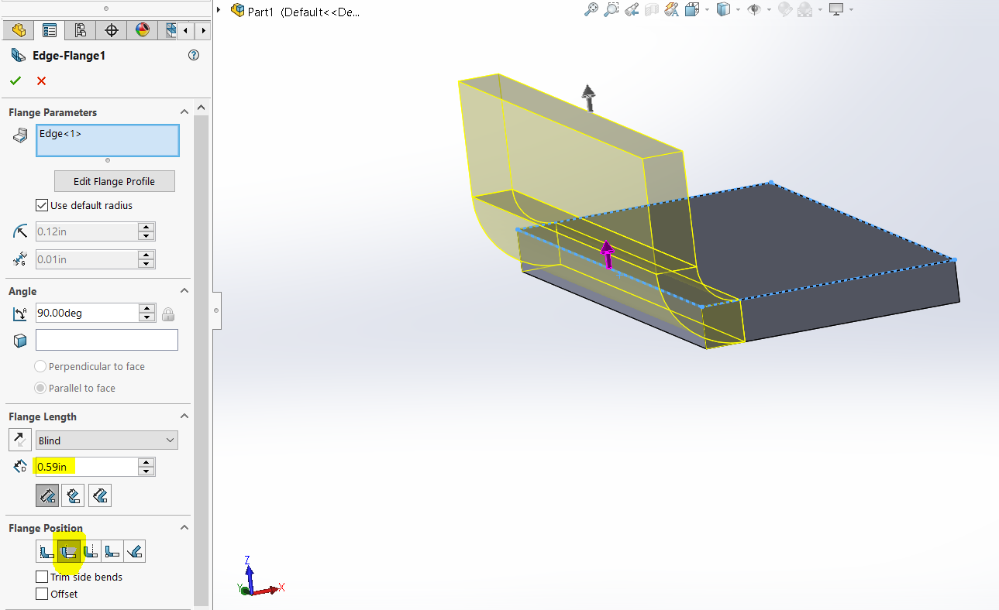

## Poor Design Example

1. Below is something that you should not do. This small flange, and the bend areas highlighted in yellow, would be “impossible” to bend since all the side flanges interfere with each other, and the material would have to be torn to make this small flange’s bend. **One possible solution is….**

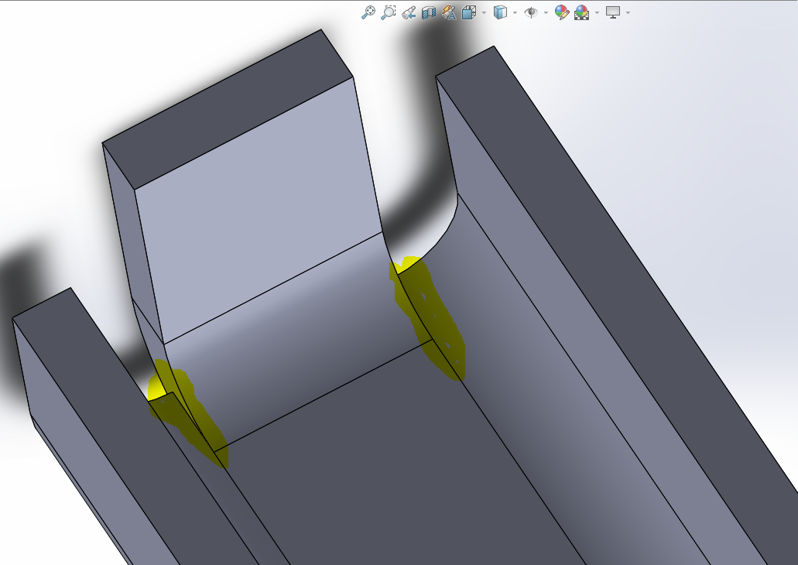

Small flange, causing issues

1. Select “Trim side bends” or…

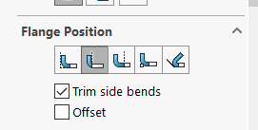

This automatically removes material such that the position of the flange does not move, but the part is now manufacturable.

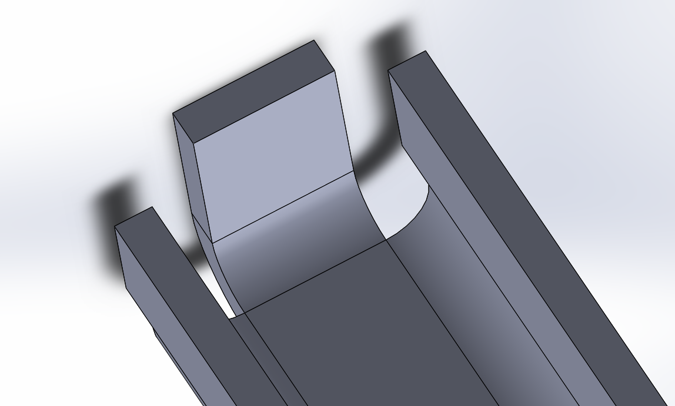

1. Change the flange position
   1. Not advised for reasons discussed before. But can work if nothing else is available

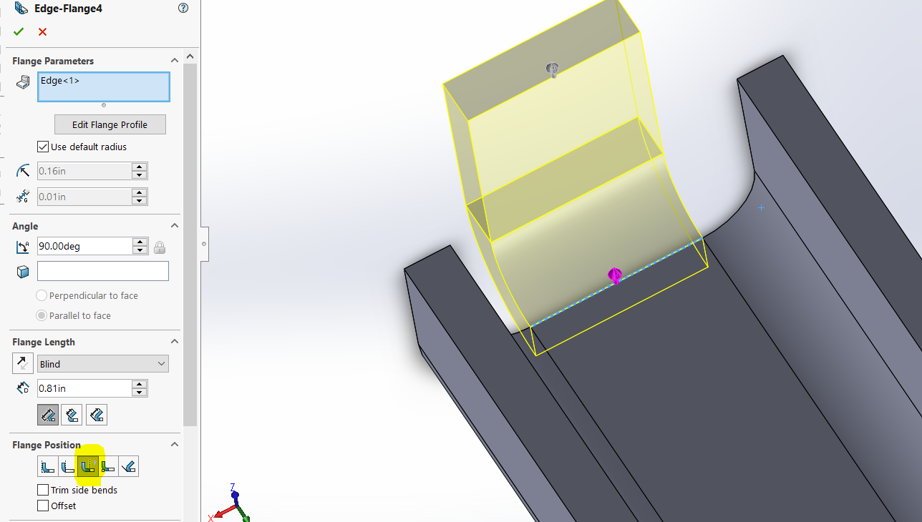

# Making a Part Drawing

1. **UPDATE YOUR DRAWING TEMPLATES PER THE OTHER DOCUMENT IN THIS FOLDER: “How To - Installing Templates and Formats”**
2. File -> Make drawing from part

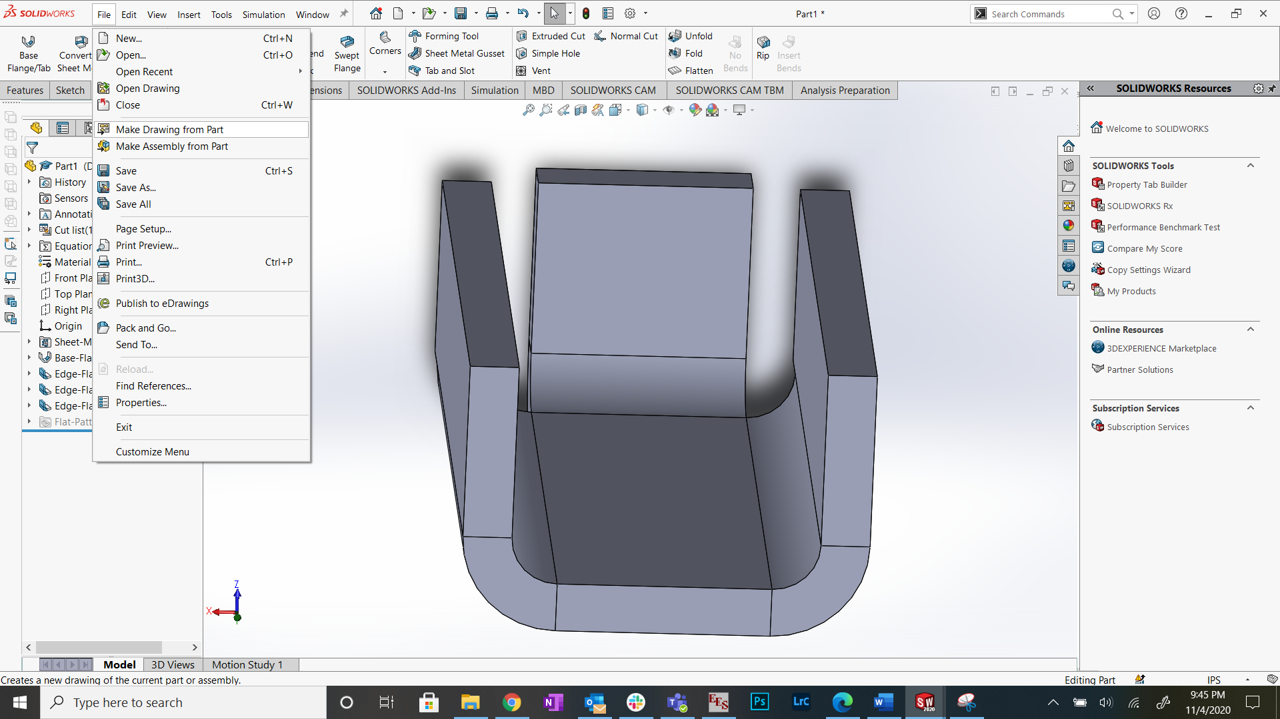



1. Save the drawing the same name as the part, but in the subsystem’s sheet metal drawings folder

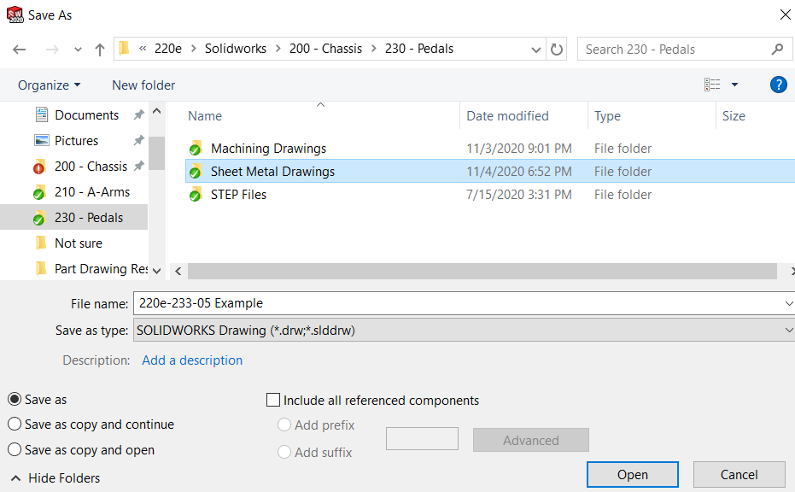

1. Turn on “Leading zeros” so its easier for the manufacturer
   1. Only need to do this if changing the sheet format from an old format
   2. Drawing templates already have this setting turned on

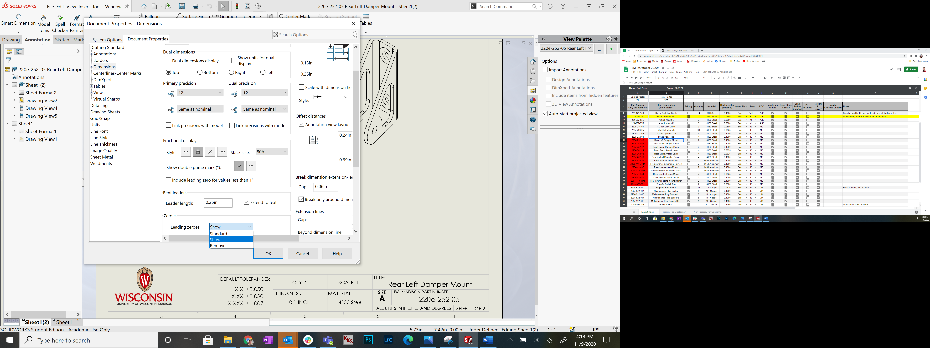



## Sheet 1: Formed Part Drawing

1. Industry standard is to have the formed part drawing be the first of two sheets
2. Drag in standard 3 views and isometric view from the “View Palette”
   1. Be sure to have the isometric view to help the manufacturer

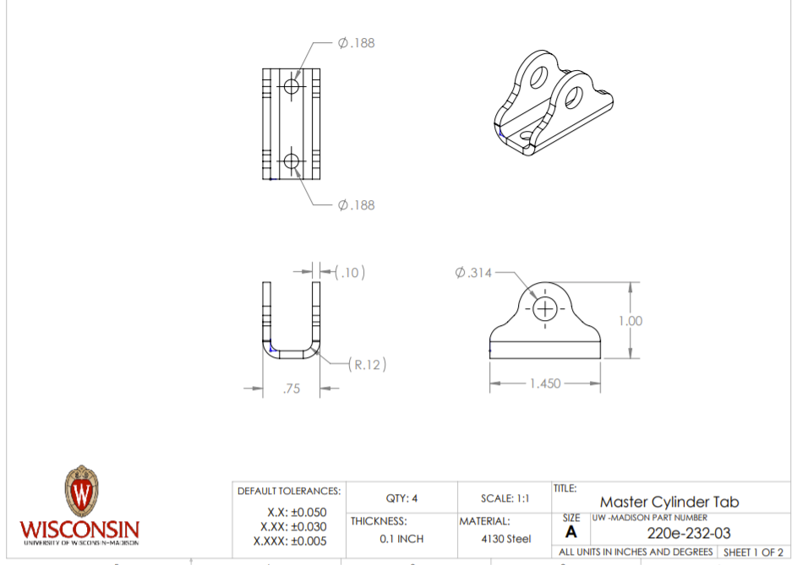

### Tolerance/Dimensioning Formed Part Drawings

1. From email with supplier, **0.030 inch tolerance is a pretty standard tolerance for formed parts**. Any tighter and the cost goes up. Use the following table to select your tolerance
   1. X.X is good for parts that are not very critical, and difficult to bend because they have multiple bends, complex geometry, etc. Should help keep cost down by keeping tolerance up

|  |  |
| --- | --- |
| **How much do you care about the dimension** | **What the tolerance should be** |
| This dimension does not matter, keep costs low | X.X: +- 0.050 |
| I want this dimension to come out good | X.XX: +-0.030 |
| I really care about this dimension and  will pay the extra money to get it right (rare) | +- 0.01 to +- 0.02 |

1. Apply these tolerances by changing the number of decimals used on your dimensions to match those in the tolerance block

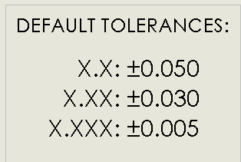

1. Make redundant dimensions into reference dimensions, but you must include them
   1. Bend radius
   2. Material thickness

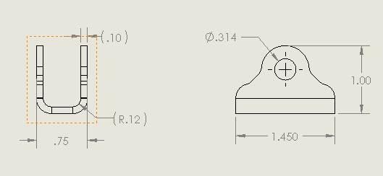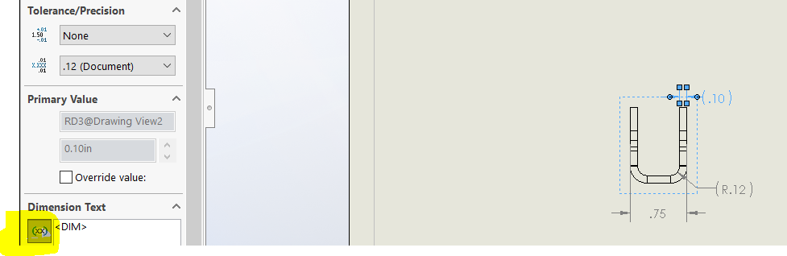

Click this to make a reference dimension on existing dimension



1. Include the laser cut dimensions as well
   1. Will talk about those tolerances later, but should make the dimension have 3 decimal places

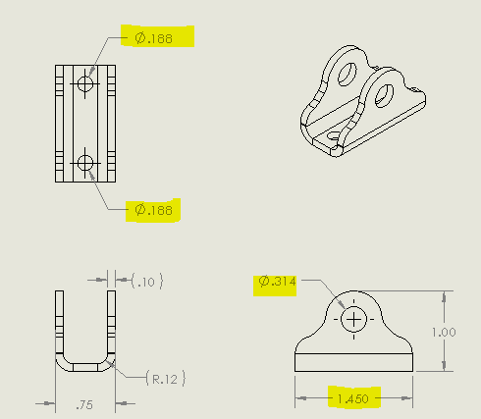

1. Right click anywhere on the drawing -> Edit Sheet Format
   1. Fill out all the boxes

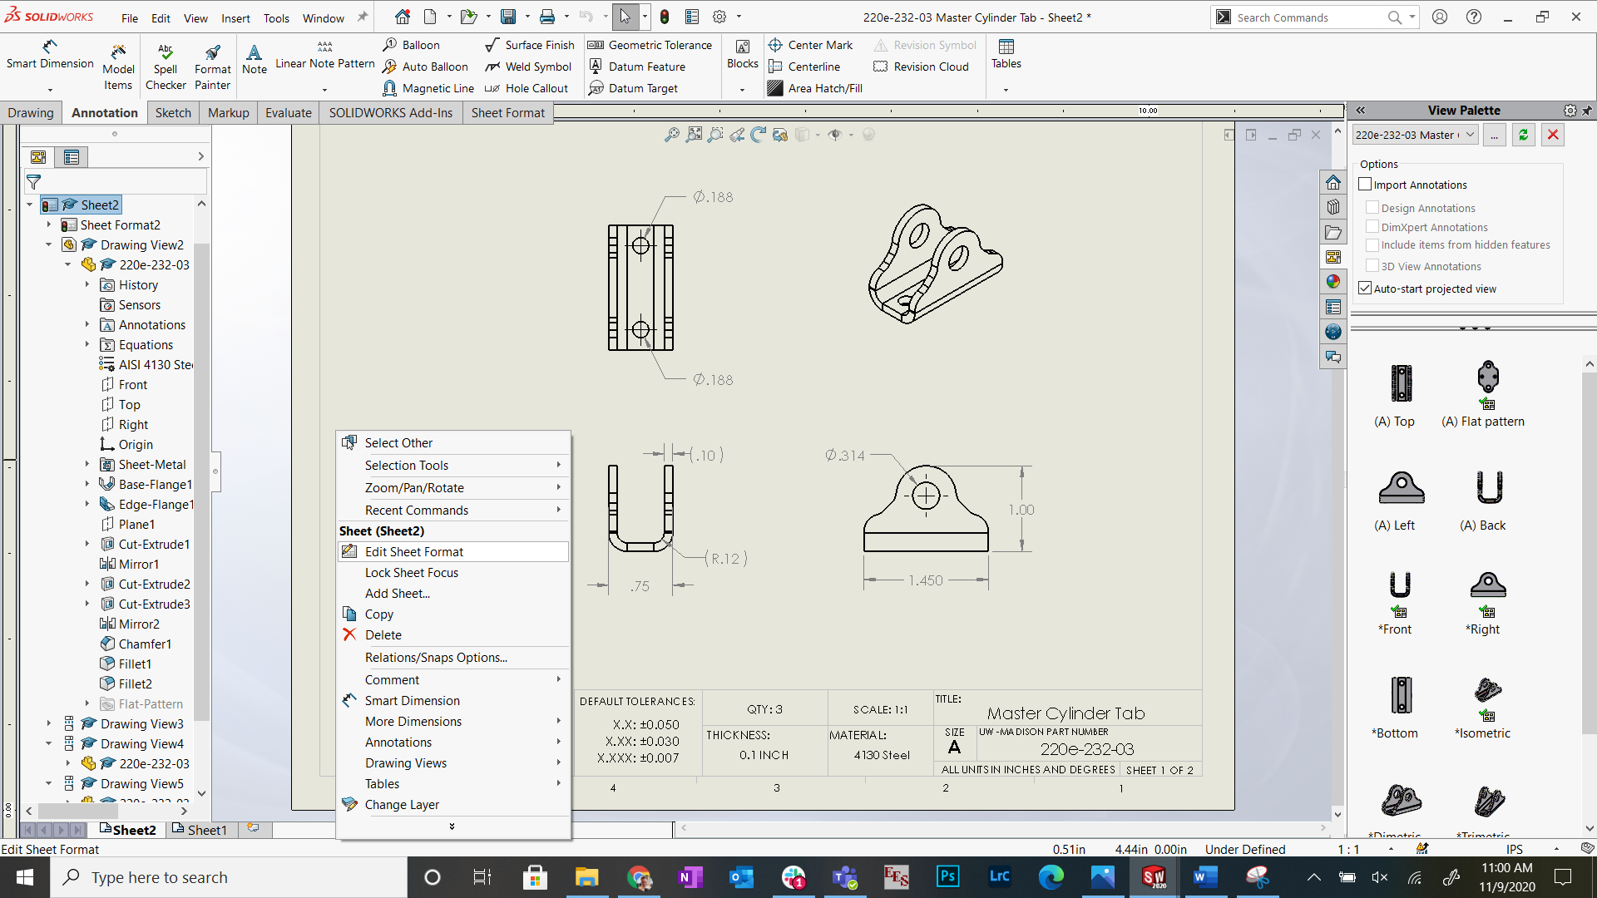



## Sheet 2: Laser Cut Part Drawing

1. Add another sheet to the drawing by right clicking on sheet 1 in the model tree -> add sheet
2. Drag in the flat pattern from the “View Palette”
   1. Flat pattern automatically flattens the part and shows the bend lines and bend parameters
   2. Ignore the drawing template – it was old when I made this

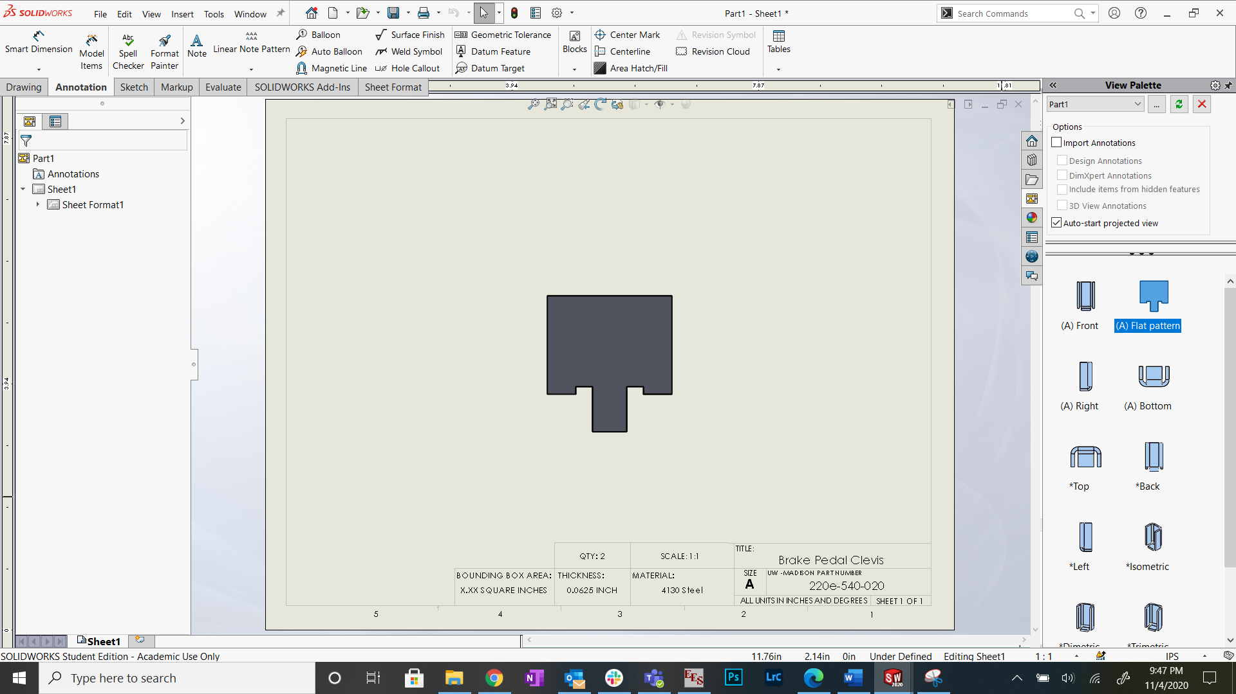



1. Make sure your bend parameters are visible, move them and add leader lines if needed

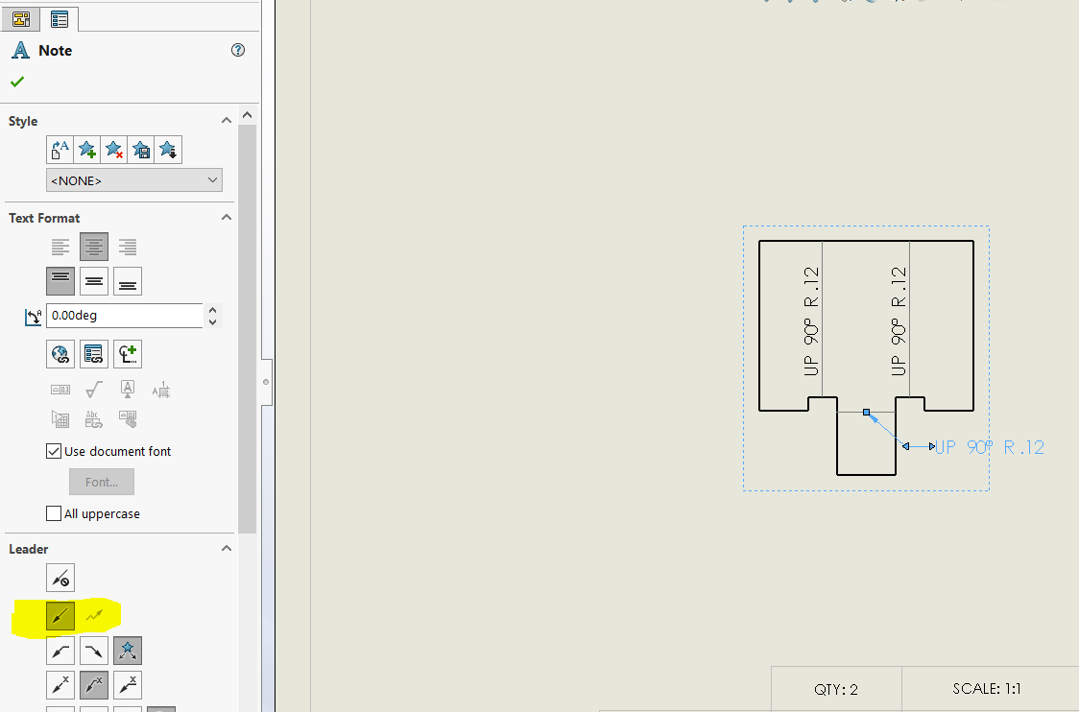

### Tolerance/Dimensioning Laser Cut Drawings

1. From email with supplier, sticking to around +- 0.005 inches for laser cut tolerancing is good
   1. **0.005 inches will be the default tolerance in the sheet metal drawing templates for laser cut dimensions**
2. Add bounding box dimensions
   1. Rectangular area required to encompass the part
   2. Used to calculate how much material is needed by supplier
   3. **Use 3 decimal places** since that is what our default tolerance block calls for the laser cut tolerance

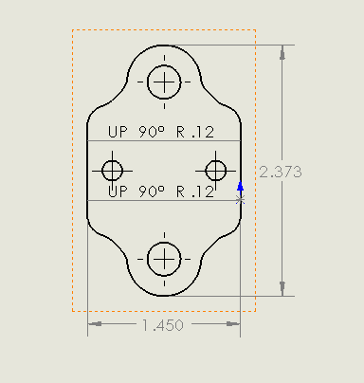



1. Right click anywhere on the drawing -> Edit Sheet Format
   1. Fill out all the boxes





1. Exit “Edit Sheet Format” before saving the drawing as a PDF
   1. If you don’t close “Edit Sheet Format” the part does not show up in the PDF
   2. Save it in your sheet metal drawings folder with the .slddrw file as well

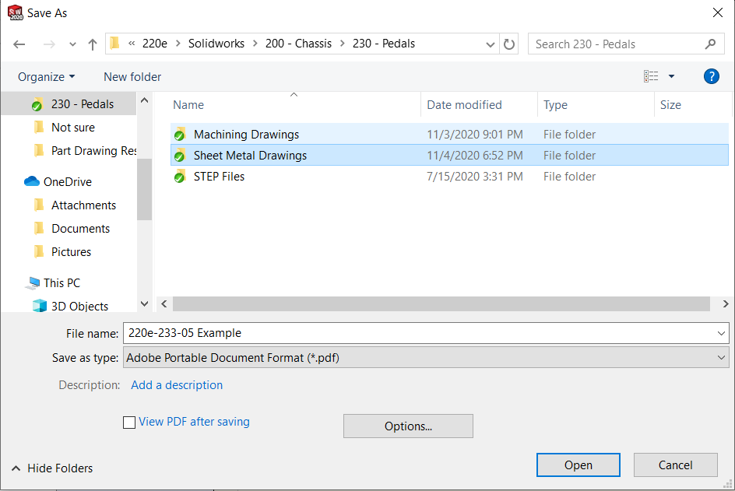

## **Changing dimensions to show outside radius, not center of arc**

1. If your part has a radius on the bounding box, change the dimension to show the “max arc condition”

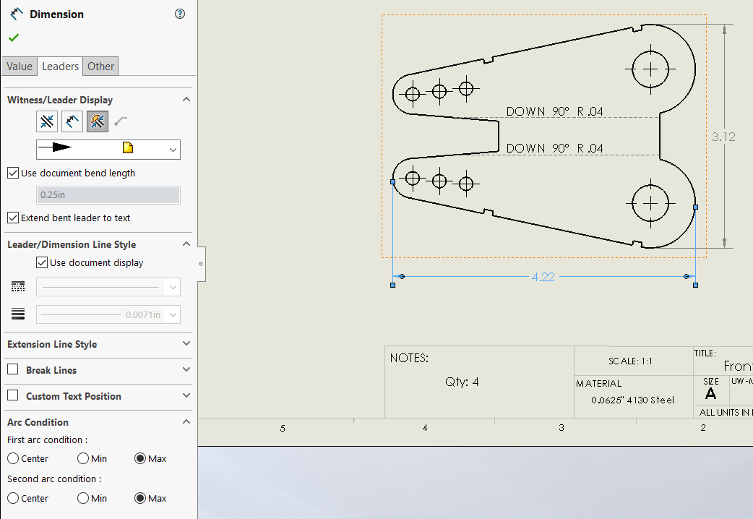



1. Done!

# EMP Lead Time (and most lead times)

* 3 week lead time for new parts
* 2 week lead time for repeat parts (parts which the company cut before)
  + This is from Gina at EMP